MYSQL Reinforcement Project

1.Count the total number of records in each table of the database

SELECT 'movie' AS table_name, COUNT(*) AS total_records FROM movie

UNION ALL

SELECT 'genre', COUNT(*) FROM genre

UNION ALL

SELECT 'director_mapping', COUNT(*) FROM director_mapping

UNION ALL

SELECT 'role_mapping', COUNT(*) FROM role_mapping

UNION ALL

SELECT 'names', COUNT(*) FROM names

UNION ALL

SELECT 'ratings', COUNT(*) FROM ratings; 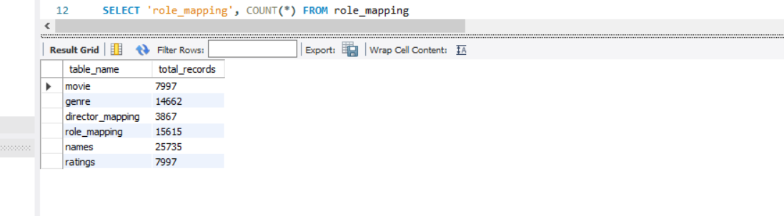

2. Identify which columns in the movie table contain null values

SELECT

SUM(CASE WHEN title IS NULL THEN 1 ELSE 0 END) AS null_titles,

SUM(CASE WHEN year IS NULL THEN 1 ELSE 0 END) AS null_years,

SUM(CASE WHEN date_published IS NULL THEN 1 ELSE 0 END) AS null_date_published,

SUM(CASE WHEN duration IS NULL THEN 1 ELSE 0 END) AS null_duration,

SUM(CASE WHEN country IS NULL THEN 1 ELSE 0 END) AS null_country,

SUM(CASE WHEN worlwide_gross_income IS NULL THEN 1 ELSE 0 END) AS null_worlwide_gross_income,

SUM(CASE WHEN languages IS NULL THEN 1 ELSE 0 END) AS null_languages,

SUM(CASE WHEN production_company IS NULL THEN 1 ELSE 0 END) AS null_production_company

FROM movie;



3. Determine the total number of movies released each year, and analyze how the trend changes month-wise.

SELECT

year AS release_year,

COUNT(*) AS total_movies

FROM movie

GROUP BY year

ORDER BY release_year;

#3 (2 ) Monthwise releaed

SELECT

YEAR(date_published) AS release_year,

MONTH(date_published) AS release_month,

COUNT(*) AS total_movies

FROM movie

WHERE date_published IS NOT NULL

GROUP BY release_year, release_month

ORDER BY release_year, release_month;

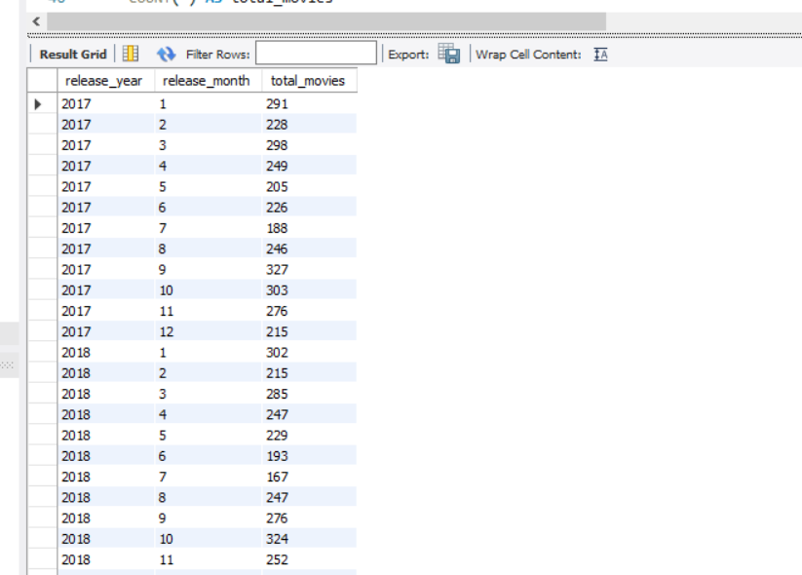

4.How many movies were produced in either the USA or India in the year 2019?

SELECT COUNT(*) AS total_movies_usa_india_2019

FROM movie

WHERE year = 2019

AND (

country LIKE '%USA%'

OR country LIKE '%India%'

);

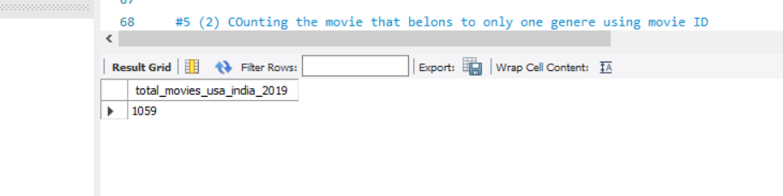

5. List the unique genres in the dataset, and count how many movies belong exclusively to one genre.

SELECT DISTINCT genre

FROM genre

ORDER BY genre;

#5 (2) COunting the movie that belons to only one genere using movie ID

SELECT COUNT(*) AS movies_with_one_genre

FROM (

SELECT movie_id

FROM genre

GROUP BY movie_id

HAVING COUNT(*) = 1

) AS single_genre_movies;

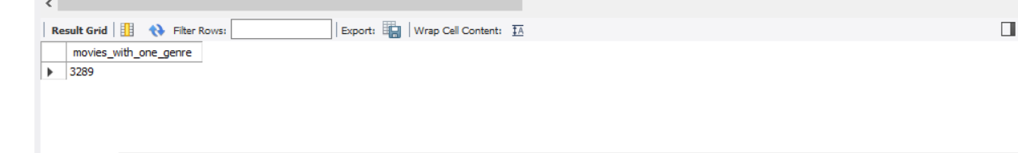

6. Which genre has the highest total number of movies produced

SELECT genre, COUNT(*) AS total_movies

FROM genre

GROUP BY genre

ORDER BY total_movies DESC

LIMIT 1;

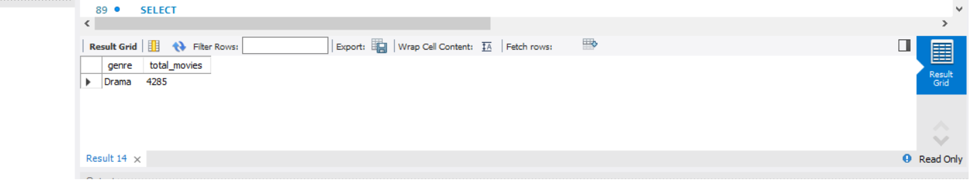

7.Calculate the average movie duration for each genre

SELECT

g.genre,

ROUND(AVG(m.duration), 2) AS avg_duration

FROM genre g

JOIN movie m ON g.movie_id = m.id

WHERE m.duration IS NOT NULL

GROUP BY g.genre

ORDER BY avg_duration DESC;

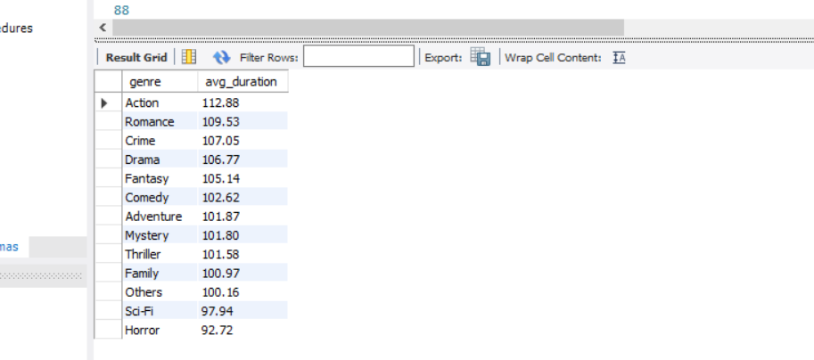

8. Identify actors or actresses who have appeared in more than three movies with an average rating below 5.

SELECT

n.name,

COUNT(*) AS low_rated_movie_count

FROM role_mapping rm

JOIN ratings r ON rm.movie_id = r.movie_id

JOIN names n ON rm.name_id = n.id

WHERE r.avg_rating < 5

GROUP BY n.name

HAVING COUNT(*) > 3

ORDER BY low_rated_movie_count DESC;

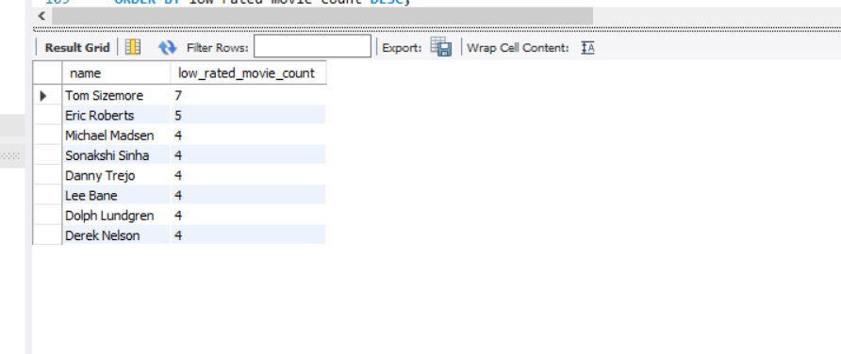

9. Find the minimum and maximum values for each column in the ratings table, excluding the movie_id column.

SELECT

MIN(avg_rating) AS min_avg_rating,

MAX(avg_rating) AS max_avg_rating,

MIN(total_votes) AS min_total_votes,

MAX(total_votes) AS max_total_votes,

MIN(median_rating) AS min_median_rating,

MAX(median_rating) AS max_median_rating

FROM ratings;

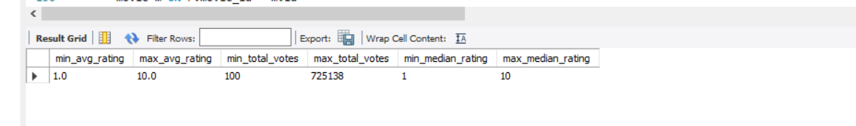

10. Which are the top 10 movies based on their average rating

SELECT

m.title,

r.avg_rating

FROM

ratings r

JOIN

movie m ON r.movie_id = m.id

ORDER BY

r.avg_rating DESC

LIMIT 10;

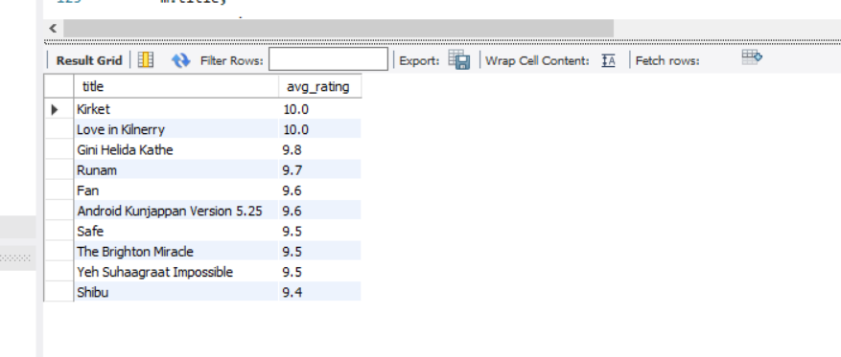

11. Summarize the ratings table by grouping movies based on their median ratings.

SELECT

median_rating,

COUNT(*) AS movie_count,

AVG(avg_rating) AS average_of_avg_rating,

SUM(total_votes) AS total_votes

FROM

ratings

GROUP BY

median_rating

ORDER BY

median_rating;

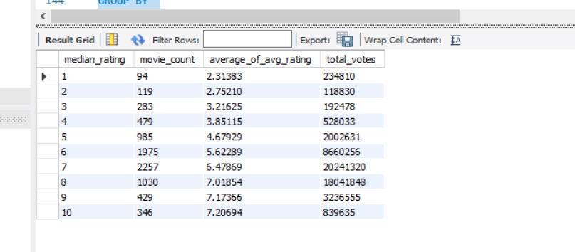

12. How many movies, released in March 2017 in the USA within a specific genre, had more than 1,000 votes?

SELECT

COUNT(*) AS movie_count

FROM

movie m

JOIN

genre g ON m.id = g.movie_id

JOIN

ratings r ON m.id = r.movie_id

WHERE

MONTH(m.date_published) = 3

AND YEAR(m.date_published) = 2017

AND m.country LIKE '%USA%'

AND g.genre = 'SPECIFIC_GENRE'

AND r.total_votes > 1000;



13. Find movies from each genre that begin with the word “The” and have an average rating greater than 8.

SELECT

g.genre,

m.title,

r.avg_rating

FROM

movie m

JOIN

ratings r ON m.id = r.movie_id

JOIN

genre g ON m.id = g.movie_id

WHERE

m.title LIKE 'The %'

AND r.avg_rating > 8

ORDER BY

g.genre, r.avg_rating DESC;

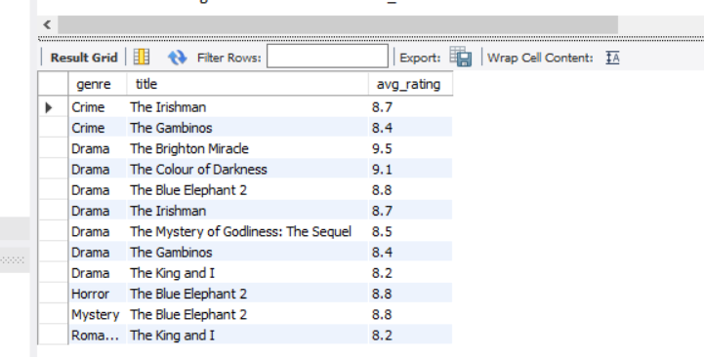

14. Of the movies released between April 1, 2018, and April 1, 2019, how many received a median rating of 8?

SELECT COUNT(*) AS movie_count

FROM movie m

JOIN ratings r ON m.id = r.movie_id

WHERE

m.date_published >= '2018-04-01'

AND m.date_published < '2019-04-02'

AND r.median_rating = 8;

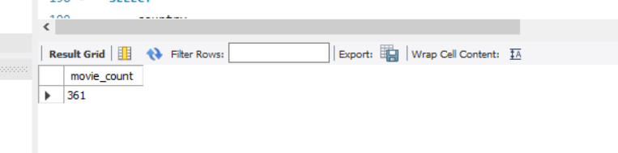

15. Do German movies receive more votes on average than Italian movies?

SELECT

country,

AVG(r.total_votes) AS average_votes

FROM

movie m

JOIN

ratings r ON m.id = r.movie_id

WHERE

country LIKE '%Germany%' OR country LIKE '%Italy%'

GROUP BY

country;

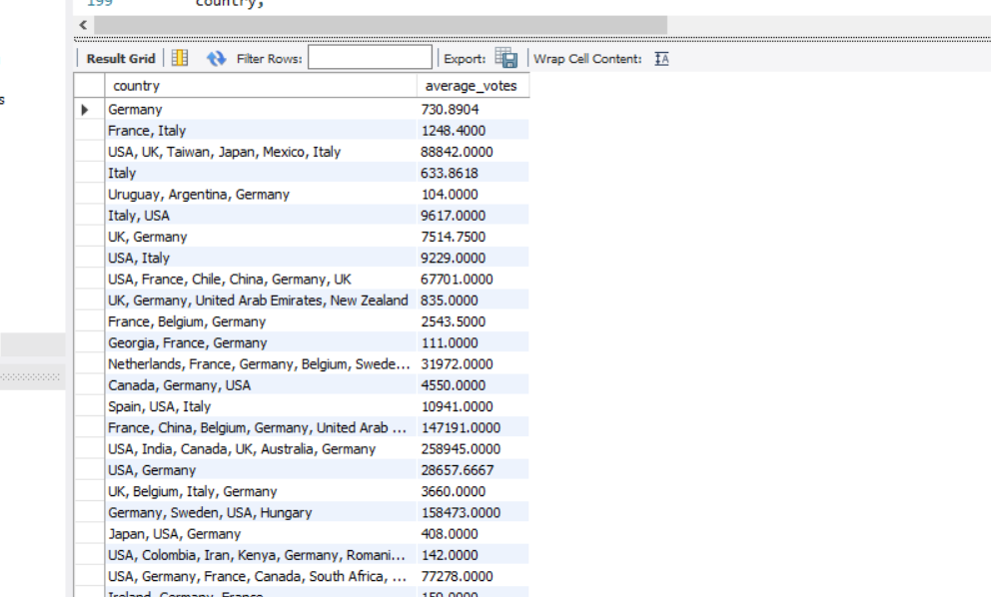

16. Identify the columns in the names table that contain null values.

SELECT

SUM(CASE WHEN name IS NULL THEN 1 ELSE 0 END) AS name_nulls,

SUM(CASE WHEN height IS NULL THEN 1 ELSE 0 END) AS height_nulls,

SUM(CASE WHEN date_of_birth IS NULL THEN 1 ELSE 0 END) AS date_of_birth_nulls,

SUM(CASE WHEN known_for_movies IS NULL THEN 1 ELSE 0 END) AS known_for_movies_nulls

FROM

names;

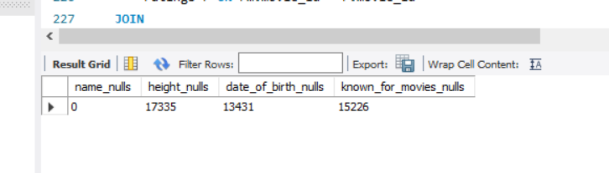

17. Who are the top two actors whose movies have a median rating of 8 or higher?

SELECT

n.name,

COUNT(*) AS high_rated_movies

FROM

role_mapping rm

JOIN

ratings r ON rm.movie_id = r.movie_id

JOIN

names n ON rm.name_id = n.id

WHERE

rm.category = 'actor'

AND r.median_rating >= 8

GROUP BY

n.name

ORDER BY

high_rated_movies DESC

LIMIT 2;

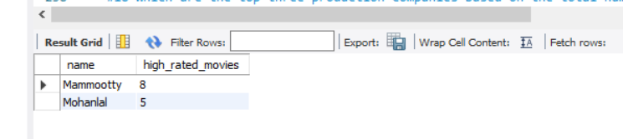

18. Which are the top three production companies based on the total number of votes their movies received?

SELECT

m.production_company,

SUM(r.total_votes) AS total_votes

FROM

movie m

JOIN

ratings r ON m.id = r.movie_id

WHERE

m.production_company IS NOT NULL

GROUP BY

m.production_company

ORDER BY

total_votes DESC

LIMIT 3;



19. How many directors have worked on more than three movies?

SELECT COUNT(*) AS director_count

FROM (

SELECT name_id

FROM director_mapping

GROUP BY name_id

HAVING COUNT(movie_id) > 3

) AS prolific_directors;

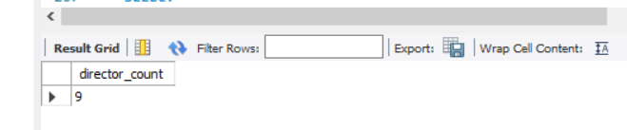

20. Calculate the average height of actors and actresses separately

SELECT

category,

AVG(height) AS average_height

FROM

role_mapping rm

JOIN

names n ON rm.name_id = n.id

WHERE

category IN ('actor', 'actress') AND height IS NOT NULL

GROUP BY

category;

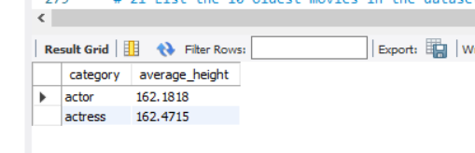

21. List the 10 oldest movies in the dataset along with their title, country, and director

SELECT

m.title,

m.country,

n.name AS director_name,

m.year

FROM

movie m

JOIN

director_mapping dm ON m.id = dm.movie_id

JOIN

names n ON dm.name_id = n.id

ORDER BY

m.year ASC

LIMIT 10;

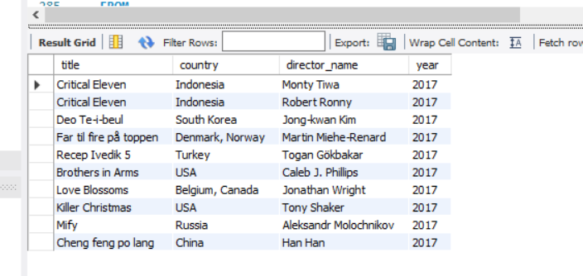

22. List the top 5 movies with the highest total votes, along with their genres.

SELECT

m.title,

r.total_votes,

GROUP_CONCAT(g.genre ORDER BY g.genre SEPARATOR ', ') AS genres

FROM

ratings r

JOIN

movie m ON r.movie_id = m.id

JOIN

genre g ON m.id = g.movie_id

GROUP BY

m.id, m.title, r.total_votes

ORDER BY

r.total_votes DESC

LIMIT 5; 

23. Identify the movie with the longest duration, along with its genre and production company

SELECT

m.title,

m.duration,

GROUP_CONCAT(g.genre ORDER BY g.genre SEPARATOR ', ') AS genres,

m.production_company

FROM

movie m

JOIN

genre g ON m.id = g.movie_id

WHERE

m.duration = (SELECT MAX(duration) FROM movie)

GROUP BY

m.id, m.title, m.duration, m.production_company;



24. Determine the total number of votes for each movie released in 2018.

SELECT

m.title,

r.total_votes

FROM

movie m

JOIN

ratings r ON m.id = r.movie_id

WHERE

m.year = 2018;

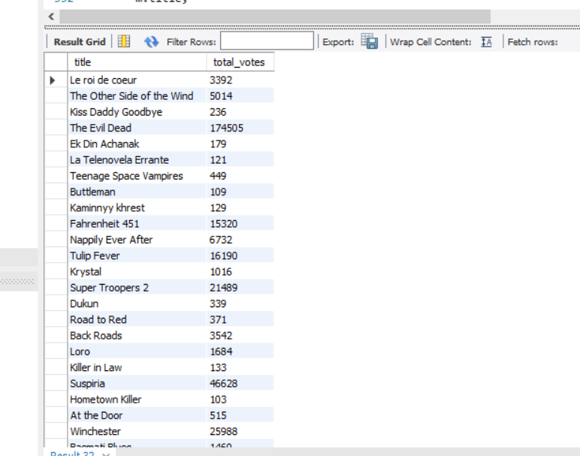

25. What is the most common language in which movies were produced

SELECT

TRIM(SUBSTRING_INDEX(languages, ',', 1)) AS primary_language,

COUNT(*) AS movie_count

FROM

movie

WHERE

languages IS NOT NULL

GROUP BY

primary_language

ORDER BY

movie_count DESC

LIMIT 01;

